Chapter 12, Solution 40.

Transform the delta-connected load to its wye equivalent.
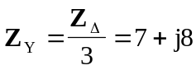

Using the per-phase equivalent circuit above,
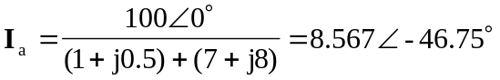

For a wye-connected load,
